13 July 2004

High Degree Of Atrocity: Exciting! Poignant! Daring!

Hong Kong Author Creates Candid Fiction

Hong Kong – In a heart-thumping new novel High Degree Of Atrocity, ex-journalist Jay Scott Kanes becomes the first English-language author to deal candidly through fiction with Hong Kong’s divisive political future.

Residents of Hong Kong simmer and fret, trapped between their yearnings for political freedom and the Beijing leadership’s intolerance. “High Degree Of Atrocity’s plot emerges from real-life political turmoil,” says Kanes. “The fictional events reflect reality, albeit a worst-case scenario.

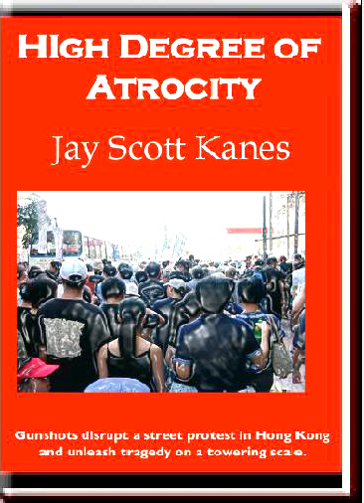 | “By writing this book, I attempt to protect Hong Kong from prospects the plot may come true. Maybe explosive fiction can repel sinister forces to the north that consistently threaten Hong Kong’s autonomy and freedoms.”  “Fortunately, readers everywhere can enjoy the dilemmas, dangers and excitement oozing from High Degree Of Atrocity.

“My earliest inspiration came 15 years ago,” Kanes said. “The Beijing Massacre, when innocent students died at the hands of People’s Liberation Army soldiers on June 4th, 1989, ranks as the most shocking news event of my lifetime. The Chinese government’s refusal to acknowledge tragic injustices on that deadly day reflects the national leadership’s persistent shortcomings. Hong Kong people legitimately fear more atrocities.”

The book carries a poignant dedication to hundreds of millions of Asians too long denied the basic freedom of meaningful democracy.

“Based on global values of freedom, this highly-entertaining Asian tale carries special meaning and a powerful impact,” Kanes said.

ABOUT THE PLOT

In the summer of 2009, turbulent Hong Kong lacks democracy while hobbled with a bungling government under close supervision from China’s central leadership.

A mysterious man joins a street demonstration as part of a conspiracy to topple Wong Kai-king, Hong Kong’s unpopular chief executive. As angry citizens march for democracy, two twitches on the trigger of a handgun leave a pair of important people sprawled lifeless on the sidewalk.

Those gunshots, amplified by three eventful days and the city’s political quagmire, unleash the worst nightmare imaginable. Scowling PLA soldiers brandish weapons and strike fear on crowded streets. Spilled blood flows in crimson rivulets. Political fault-lines rumble all the way from Beijing to Washington.

Danger lurks behind every skyscraper. Amid the chaos, democracy campaigner Elsie Chan-Barrett and her husband Blair must struggle to survive while keeping alive an entire city’s flickering hopes for a better future.

Their leading adversaries, Chinese president Teng Jiheng, his Hong Kong director Yang Fengfu and PLA major-general Zhang Bingde, rank among Asia’s most powerful people. Remarkable characters like PLA sharpshooter Guo Bijian, luckless gambler Chan Ying-po, democracy activist Arthur Liu, US president Nancy Lang and CNN correspondent Angela Jones refuse to be overshadowed. From the impoverished child Hou Choi-yee to ancient Communist cadre Xie Xuetao, the book’s carefully crafted characters reflect the diversity of China.

High Degree Of Atrocity, 338 pages, AuthorHouse, ISBN: 1-4184-2650-4

Order Online at: www.jayscottkanes.com
www.amazon.com
www.BN.com
www.paddyfield.com

Purchase In Person:
Flow Book Shop, 1/F, 40 Lyndhurst Terrance (on the escalator), Central, Hong Kong, Tel: 2964-9483, 8104-0822
Flow Book Shop, 1/F, 16 Wan King Path, Sai Kung, Hong Kong, Tel: 8207-6828 (weekends only)
Lamma Island (For delivery in or near Yung Shue Wan, telephone 2361-1143)

In Leading Bookstores: order by citing ISBN 1-4184-2650-4

ABOUT THE AUTHOR

An astute Asia-watcher, first-time author Jay Scott Kanes crossed the Pacific in time to experience Hong Kong’s return to Chinese sovereignty and the aftermath.

Born in Prince Edward Island, Canada’s smallest province, Kanes grew up driving tractors and milking cows on a prolific dairy farm. Later, he roamed center-court for a high-school basketball team and listened attentively in creative-writing classes.

His journalism career began with The Sault Star newspaper in Sault Ste. Marie, Ontario, and then The Leader-Post in Regina, Saskatchewan.

“My first assignments filled sports pages in the steel-making city of Sault Ste. Marie, across the St. Mary’s River from Michigan’s Upper Peninsula,” Kanes said. “Gradually, I advanced from ice hockey and gridiron to city-council meetings and national-election coverage.”

Links to Asia developed fast after he first visited the region in 1986. “Moving from big-sky country on the Canadian prairies to the skyscraper-canyons in Hong Kong caused significant lifestyle changes,” Kanes said. “Instead of gnawing on beef steaks, I began to slurp soup noodles.”

“Initially, I edited a magazine called Arts of Asia,” Kanes said. Later, he supervised editorial contents for business titles like Hong Kong Trade Services, Hong Kong Electronics and Hong Kong Jewellery Collection.

During Hong Kong’s difficult 1997 transformation from a British colony into a Chinese special administrative region, Kanes worked as an insider in Hong Kong's government sector.

“Among other tasks, I prepared promotional prose for overseas distribution by the Hong Kong Trade Development Council,” said Kanes.

*******

More information: email jayscottkanes@cairnsmedia.com; Tel (852) 2361-1143.

