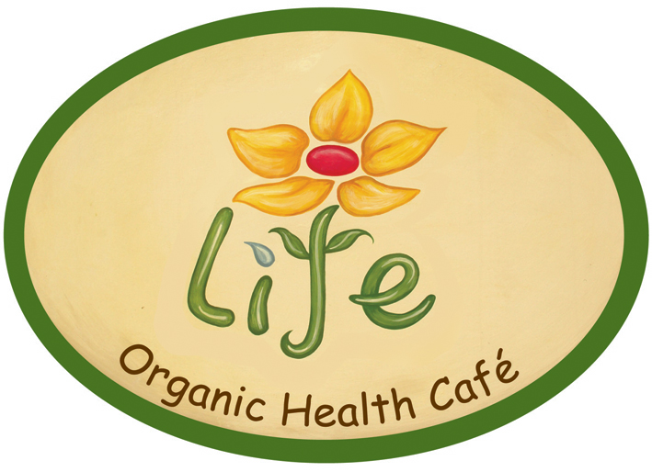

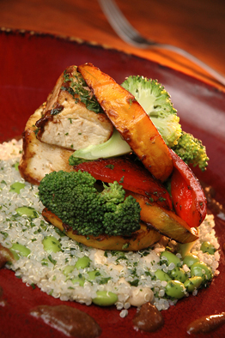

Asian Stir-Fry $90
Tofu, pumpkin, broccoli & red pepper seasoned with a tamarind, ginger & red chilli sauce, served with soyabean & cashew quinoa

V, Y, G, W, OG

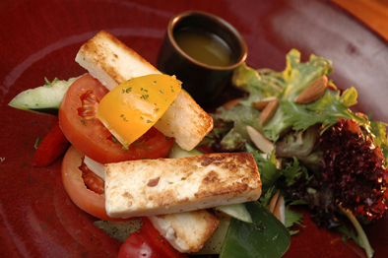
Manouri, Cucumber and Tomato Salad $95
Pan-fried manouri cheese with cucumber, mixed pepper, tomato & olives, with oregano dressing & leafy greens sprinkled with almonds

OG, Y

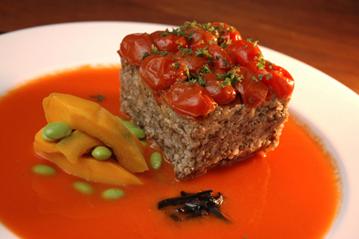
Quinoa Oat & Mushroom Bake $95
Quinoa, oats, wild mushrooms and fresh herb baked with cherry tomatoes and served with a red pepper chinese truffle sauce

V, Y, W, OG

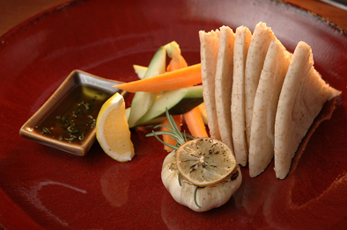

Roasted Garlic $35
A whole bulb of garlic roasted with olive oil and rosemary and served with organic wholewheat pita

V

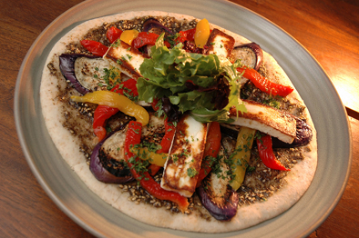
Roasted Zaatar $90
A wholewheat pita bread topped with zaatar, manouri cheese, roasted red pepper & eggplant

V – Vegan Free, G – Gluten Free, Y – Yeast Free, W – Wheat Free, OG – Onion & Garlic Free

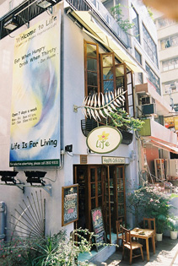
Life Exterior

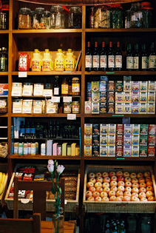

Life Deli

