“Imagining in the ruins” Photo Exhibition
Ryan Wong @ SEE

On the third floor of a renovated building with 90 years history,
we found the pictures of abandon houses in Southeast Lamma with almost the same ages
On the rough envelops that we received in the past 4 years from friends,
we figured out how the network connects each others,
telling the story of recycle, relive and resurrection

Lamma Island is well known for its exoticism. Behind the lively community near the pier, there are abandoned old communities showing how the material culture merges with nature. With concerns over the development of the community, SEE Network and photographer, Ryan Wong have been researching and taking pictures on Lamma Island. From our photos, you will find an unfamiliar Lamma, and we hope the images will inspire your visions over “Nature”, “Conservation” and “Development”. Some of the pictures in the exhibition have been put in Lamma Story, but some have never been publicized.

Imagining in the ruins Photo Exhibition
Date: 14 Nov – 14 Dec 2008
Venue: 3/F Gallery, OMM Fashion Boutique, 36 Cochrane Street, Central
For more details, please feel free to contact us at 2127 4503.

A media Preview Tour will be set for coming Friday (14/11) at 3:00pm.

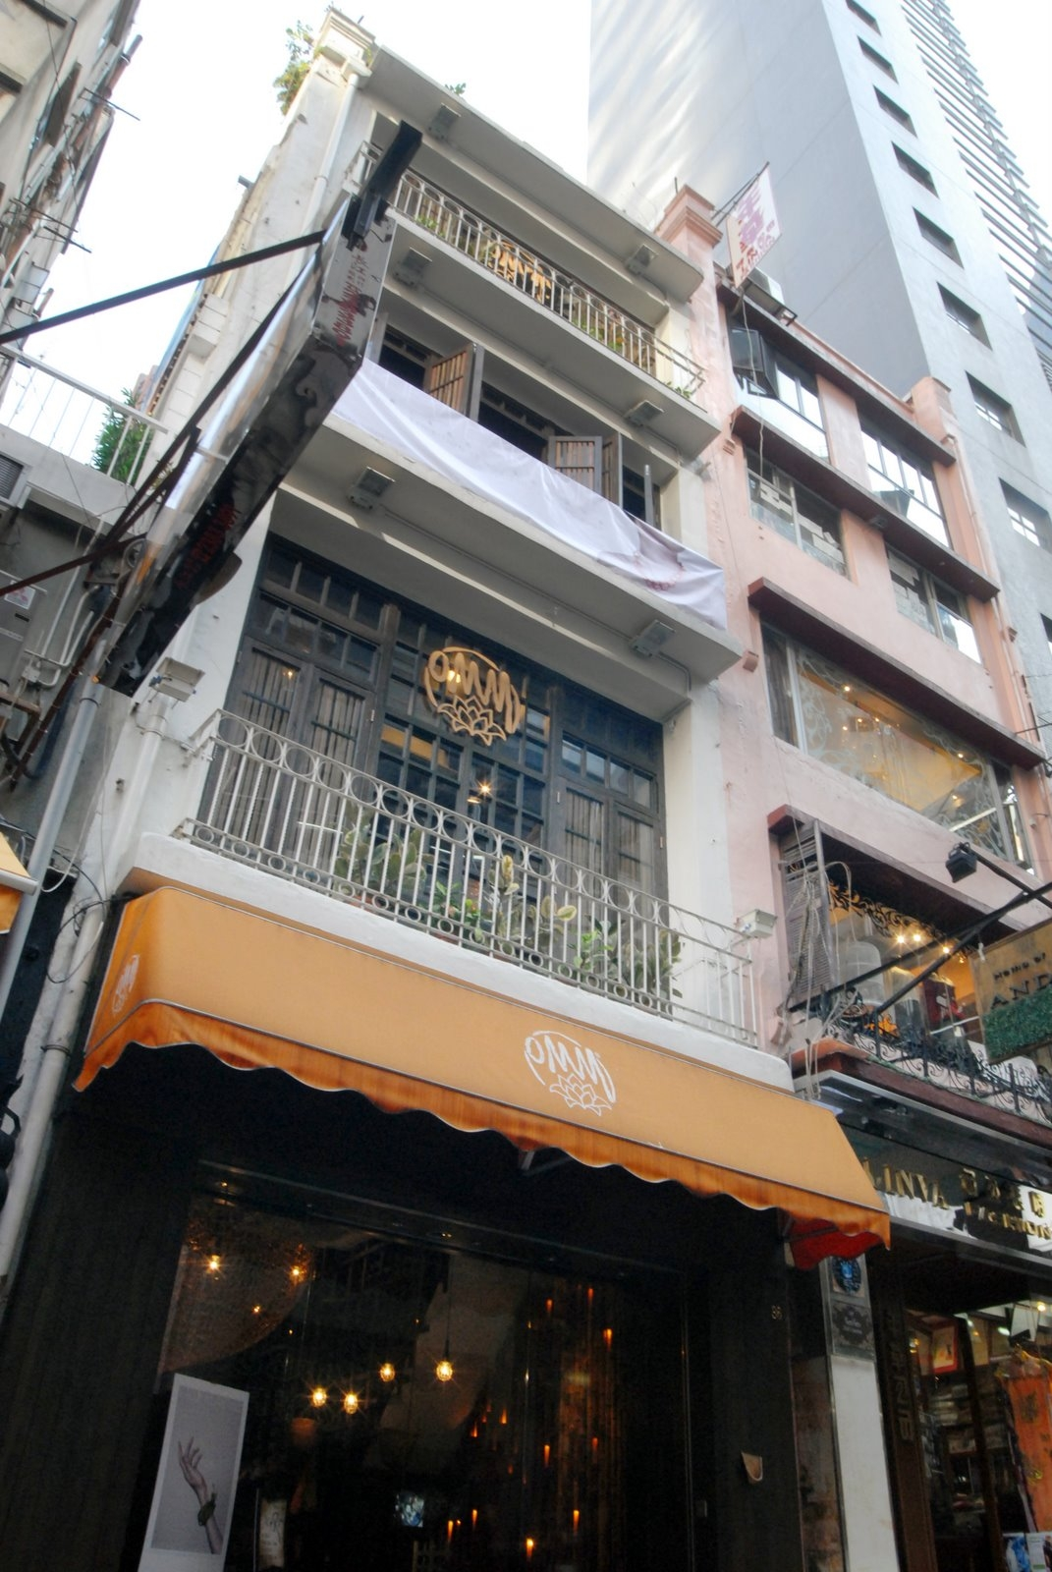
About the Venue
The venue of the photo exhibition is a pre-war heritage built in 1918. It was recently renovated and transformed into a local brand fashion boutique. With approximately the same age, the abandoned houses in South-east Lamma are having different destiny, and they are the witness to tell the logic and changes of city planning in Hong Kong.

About Ryan Wong
Born in Hong Kong and lived in Seattle, New York, and China, Ryan Wong is a professional photographer, cinematographer, and film/video director and has produced projects in the United States and China. In 2003 he graduated from NYU's Tisch School of the Arts with a BA in Film/TV production. His photographic and film/video works have been shown at different places, e.g. the Louis Vuitton Hawaiian International Film Festival, the National Geographic Society in Washington D.C., the Hong Kong International Film Festival, and Blue Lotus Gallery. Most recently at the Hamptons International Film Festival with his feature documentary directorial debut "The Road Ahead : The First Green Long March."

Currently based in Hong Kong but doing lots of traveling, he is the now the assistant to actor and NGO leader Jet Li, working in all aspects of both the entertainment and NGO field stateside and in Asia.

About SEE Network
Our services include: tailor-made publication services (from research to publishing), consultation, organizing public engagement events, local and overseas cultural study tour. To know more about SEE, please visit our website: www.project-see.net.
SEE Network Ltd., set up in 2004 with government’s Sustainable Development Fund, is a cultural organization aiming to arouse our city’s concerns over sustainable development through in-depth research, publication and public activities.

“SEE” stands for three main focuses of sustainable development, i.e. Society, Environment and Economy. After all these years when our society was preoccupied fully and solely with economic development, we believe it is time to switch our focus back to humanity and environment.

