離島區打擊及防止「青少年罪案」宣傳運動2006

Islands District Fight Against Juvenile Crimes Campaign 2006

繪畫、填顏色比賽與及標語口號創作比賽
Poster/Colour Drawing and Slogan Creation Competition

報名表格

Registration form

參加者姓名： 電 話：
Participant’s name: _________________ Telephone No:___________________

參賽組別(繪畫、填顏色或標語口號創作)：
Category of the entry (poster, colour drawing or slogan competition): _____________________

就讀學校名稱及級別：
School year and name of school study: _________________________________________

參加者電郵：

E-mail address of participant: ______________________________________________

參加者地址：

Participant’s Address: _________________________________________________________________

參賽作品標題：
Artwork title: _______________________________________________________________________

聲明

本人明白及同意遵守打擊及防止「青少年罪案」宣傳運動2006繪畫、填顏色比賽與及標語口號創作比賽細則。本人謹此聲明此參賽表格所填寫之資料真確無訛，並清楚明白任何虛假資料可能導致取消資格。

參賽者簽署： 日期：_____________________________________

Declaration
I agree to abide by the rules governing the poster, colour drawing and slogan creation competitions arranged to promote the Fight Against Juvenile Crimes Campaign. I understand that any incorrect information provided in this form may lead to immediate disqualification.

Signature of participant: _______________ Date: ______________________

- 所有參賽作品必須連同報名表格一併遞交，並須張貼於參賽作品背面請將填妥參加表格，於二零零六年七月二十二日前交回長洲警署、坪洲警崗、南丫警崗或長洲、坪洲、南丫各島政務署及鄉委會辦公室，

- All Artwork must be submitted together with the registration form, and will have returned to Cheung Chau Police Station, Peng Chau and Lamma Police Posts or Home Affairs Offices and Rural Committee Offices on Cheung Chau, Peng Chau and Lamma Island on or before 22nd July, 2006.

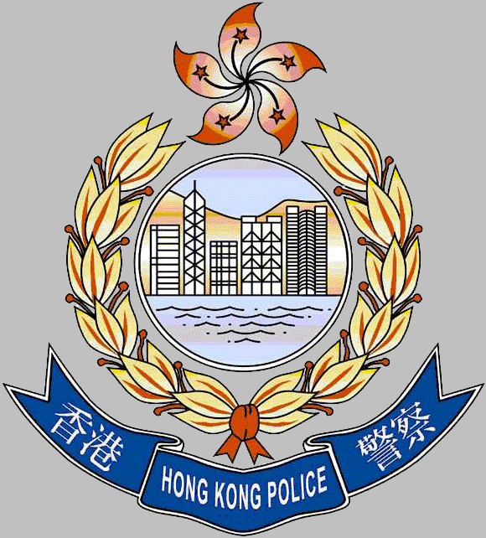

水警海港警區 離島區區議會 離島區撲滅罪行委員會

Marine Port District Islands District Council Islands District Fight Crime Committee

